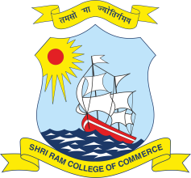 | SHRI RAM COLLEGE OF COMMERCE  University of Delhi, Maurice Nagar, Delhi – 110 007  Website: www.srcc.edu Phone: 27667905, 27666519

Date: 18.08.2020

Construction of Temporary Class Rooms
(Opining of Teachnical Bids)

The Technical Bids for the Construction of Temporary Class Rooms in the College shall be opend on Wednessday, 19.08.2020 at 11.00 pm in the Staff Room, Shri Ram College of Commerce.

Parties who have submitted their Bids are advised to remain present at the time of opening of Technical Bids as per above schedule.

PRINCIPAL

